- Write a program to display "Welcome to Java Programming".

Source Code:
WelcomeProgram_1236.java
public class WelcomeProgram_1236 {
public static void main(String[] args) { System.out.println("Welcome to Java Programming");
}
}

Output:

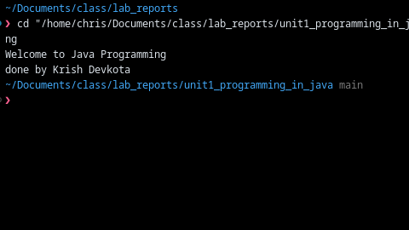
- Write a program to display id and name from user.

Source Code:
import java.util.Scanner;

public class Unit1Q02DisplayIdAndName {
public static void main(String[] args) {
Scanner scanner = new Scanner(System.in);

System.out.print("Enter id: ");
String id = scanner.nextLine().trim();

System.out.print("Enter name: ");
String name = scanner.nextLine().trim();

System.out.println("Id: " + id);
System.out.println("Name: " + name);
System.out.println("done by Krish Devkota");
}
}

Output
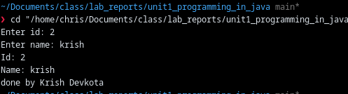

- Write a program that takes three numbers as input to calculate sum and average.
Source Code:
import java.util.Scanner;

public class Unit1Q03SumAndAverageOfThreeNumbers {
public static void main(String[] args) {
Scanner scanner = new Scanner(System.in);

System.out.print("Enter first number: ");
double a = scanner.nextDouble();
System.out.print("Enter second number: ");
double b = scanner.nextDouble();
System.out.print("Enter third number: ");
double c = scanner.nextDouble();

double sum = a + b + c;
double average = sum / 3.0;

System.out.println("Sum: " + sum);
System.out.println("Average: " + average);
System.out.println("done by Krish Devkota");
}
}

Output:
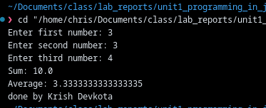
- Write a program to find the smallest of three numbers using the conditional operator.
Source Code:
import java.util.Scanner;

public class Unit1Q04SmallestOfThreeConditional {
public static void main(String[] args) {
Scanner scanner = new Scanner(System.in);

System.out.print("Enter first number: ");
double a = scanner.nextDouble();
System.out.print("Enter second number: ");
double b = scanner.nextDouble();
System.out.print("Enter third number: ");
double c = scanner.nextDouble();

double smallest = (a < b) ? ((a < c) ? a : c) : ((b < c) ? b : c);

System.out.println("Smallest: " + smallest);
System.out.println("done by Krish Devkota");
}
}

Output:
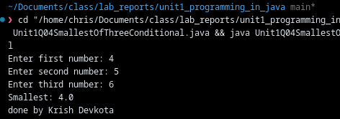
- Write a program to swap two numbers without using a third variable.
Source Code:
import java.util.Scanner;

public class Unit1Q05SwapWithoutThirdVariable {
public static void main(String[] args) {
Scanner scanner = new Scanner(System.in);

System.out.print("Enter first integer: ");
int a = scanner.nextInt();
System.out.print("Enter second integer: ");
int b = scanner.nextInt();

System.out.println("Before swap: a=" + a + ", b=" + b);

a = a ^ b;
b = a ^ b;
a = a ^ b;

System.out.println("After swap: a=" + a + ", b=" + b);
System.out.println("done by Krish Devkota");
}
}

Output:
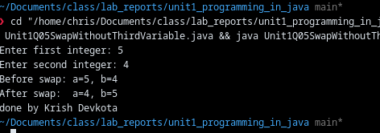

- Write a program to implement the concept of parameterized constructors.
Source Code:
public class Unit1Q06ParameterizedConstructorDemo {
public static void main(String[] args) {
Book book = new Book("Effective Java", "Joshua Bloch");
System.out.println(book);
System.out.println("done by Krish Devkota");
}

static class Book {
private final String title;
private final String author;

Book(String title, String author) {
this.title = title;
this.author = author;
}

@Override
public String toString() {
return "Book{title='" + title + "', author='" + author + "'}";
}
}
}

Output:
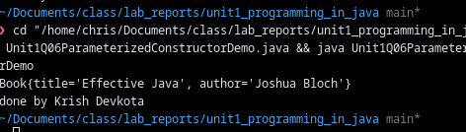

- Write a program to implement the concept of interface.

Source Code:
public class Unit1Q07InterfaceDemo {
public static void main(String[] args) {
Shape circle = new Circle(5);
Shape rectangle = new Rectangle(4, 6);

System.out.println("Circle area: " + circle.area());
System.out.println("Rectangle area: " + rectangle.area());
System.out.println("done by Krish Devkota");
}

interface Shape {
double area();
}

static class Circle implements Shape {
private final double radius;

Circle(double radius) {
this.radius = radius;
}

@Override
public double area() {
return Math.PI * radius * radius;
}
}

static class Rectangle implements Shape {
private final double width;
private final double height;

Rectangle(double width, double height) {
this.width = width;
this.height = height;
}

@Override
public double area() {
return width * height;
}
}
}

Output:
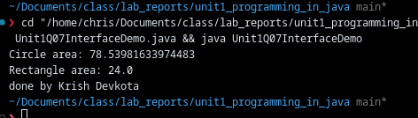
- Write a program to demonstrate the concept of overriding methods.
Source Code:
public class Unit1Q08MethodOverridingDemo {
public static void main(String[] args) {
Animal animal = new Animal();
Animal dog = new Dog();

animal.speak();
dog.speak();
System.out.println("done by Krish Devkota");
}

static class Animal {
void speak() {
System.out.println("Animal speaks");
}
}

static class Dog extends Animal {
@Override
void speak() {
System.out.println("Dog barks");
}
}
}

Output:
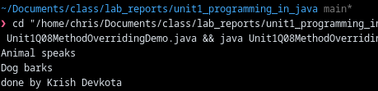

9) Write a program to demonstrate the concept of user-defined exceptions.
Source Code :
import java.util.Scanner;

public class Unit1Q09UserDefinedExceptionDemo {
public static void main(String[] args) {
Scanner scanner = new Scanner(System.in);

System.out.print("Enter a positive integer: ");
int n = scanner.nextInt();

try {
ensurePositive(n);
System.out.println("You entered: " + n);
} catch (NegativeNumberException e) {
System.out.println("Error: " + e.getMessage());
}

System.out.println("done by Krish Devkota");
}

static void ensurePositive(int n) throws NegativeNumberException {
if (n < 0) {
throw new NegativeNumberException("Number must be positive, got " + n);
}
}

static class NegativeNumberException extends Exception {
NegativeNumberException(String message) {
super(message);
}
}
} Output:

10) Write a program to demonstrate the concept of ArrayList.
Source Code:
import java.util.ArrayList;
import java.util.Collections;
import java.util.List;

public class Unit1Q10ArrayListDemo {
public static void main(String[] args) {
List<String> names = new ArrayList<>();
names.add("Krish");
names.add("Asha");
names.add("Bimal");

System.out.println("Original: " + names);

names.remove("Asha");
names.add("Sita");
Collections.sort(names);

System.out.println("Updated & sorted: " + names);
System.out.println("Contains 'Krish'? " + names.contains("Krish"));
System.out.println("done by Krish Devkota");
}
}

Output
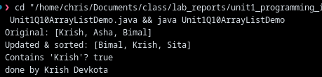
11) Write a program to demonstrate the concept of Hash table. Solution Explorer:

Source Code:
import java.util.Hashtable;
import java.util.Map;

public class Unit1Q11HashtableDemo {
public static void main(String[] args) {
Hashtable<Integer, String> students = new Hashtable<>();
students.put(1, "Krish");
students.put(2, "Sita");
students.put(3, "Ram");

for (Map.Entry<Integer, String> entry : students.entrySet()) {
System.out.println(entry.getKey() + " -> " + entry.getValue());
}

System.out.println("done by Krish Devkota");
}
}

Output
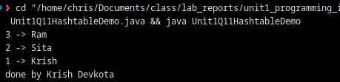
12) Write a program to demonstrate the concept of Comparator.
Source Code:
import java.util.ArrayList;
import java.util.Collections;
import java.util.List;

public class Unit1Q12ComparableDemo {
public static void main(String[] args) {
List<Employee> employees = new ArrayList<>();
employees.add(new Employee(3, "Krish", 55000));
employees.add(new Employee(1, "Sita", 65000));
employees.add(new Employee(2, "Ram", 45000));

Collections.sort(employees);
for (Employee e : employees) {
System.out.println(e);
}

System.out.println("done by Krish Devkota");
}

static class Employee implements Comparable<Employee> {
private final int id;
private final String name;
private final double salary;

Employee(int id, String name, double salary) {
this.id = id;
this.name = name;
this.salary = salary;
}

@Override
public int compareTo(Employee other) {
return Double.compare(this.salary, other.salary);
}

@Override
public String toString() {
return "Employee{id=" + id + ", name='" + name + "', salary=" + salary + "}";
}
}
}

Output

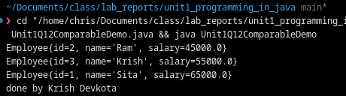

13) Write a program demonstrate the concept of synchronization.
Source Code:
public class Unit1Q13AbstractClassDemo {
public static void main(String[] args) {
Vehicle bike = new Bike();
Vehicle car = new Car();

bike.start();
car.start();
System.out.println("done by Krish Devkota");
}

abstract static class Vehicle {
abstract void start();
}

static class Bike extends Vehicle {
@Override
void start() {
System.out.println("Bike starts with kick");
}
}

static class Car extends Vehicle {
@Override
void start() {
System.out.println("Car starts with key");
}
}
}

Output:
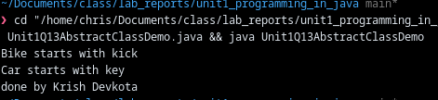

14) Write a program demonstrate the concept of Serialization.
Source Code
public class Unit1Q14SynchronizationDemo {
public static void main(String[] args) throws InterruptedException {
Counter counter = new Counter();

Thread t1 = new Thread(() -> counter.incrementMany(100_000), "T1");
Thread t2 = new Thread(() -> counter.incrementMany(100_000), "T2");

t1.start();
t2.start();

t1.join();
t2.join();

System.out.println("Final count: " + counter.get());
System.out.println("done by Krish Devkota");
}

static class Counter {
private int value;

void incrementMany(int times) {
for (int i = 0; i < times; i++) {
increment();
}
}

private synchronized void increment() {
value++;
}

synchronized int get() {
return value;
}
}
}

Output:
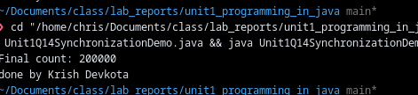

15) Write a program to demonstrate the concept of Deserialization.
Source Code
import java.io.FileOutputStream;
import java.io.IOException;
import java.io.ObjectOutputStream;
import java.io.Serializable;
import java.util.Scanner;

public class Unit1Q15SerializationDemo {
private static final String FILE_NAME = "unit1_serialization_demo.ser";

public static void main(String[] args) {
Scanner scanner = new Scanner(System.in);

System.out.print("Enter student id: ");
int id = readInt(scanner);
System.out.print("Enter student name: ");
String name = scanner.nextLine().trim();
System.out.print("Enter student age: ");
int age = readInt(scanner);

StudentRecord record = new StudentRecord(id, name.isEmpty() ? "Unknown" : name, age);

try (ObjectOutputStream out = new ObjectOutputStream(new FileOutputStream(FILE_NAME))) {
out.writeObject(record);
System.out.println("Serialized to: " + FILE_NAME);
System.out.println("Data: " + record);
} catch (IOException e) {
System.out.println("Serialization failed: " + e.getMessage());
}

System.out.println("done by Krish Devkota");
}

private static int readInt(Scanner scanner) {
while (true) {
String line = scanner.nextLine().trim();
try {
return Integer.parseInt(line);
} catch (NumberFormatException e) {
System.out.print("Please enter a valid integer: ");
}
}
}

static class StudentRecord implements Serializable {
private static final long serialVersionUID = 1L;

private final int id;
private final String name;
private final int age;

StudentRecord(int id, String name, int age) {
this.id = id;
this.name = name;
this.age = age;
}

@Override
public String toString() {
return "StudentRecord{id=" + id + ", name='" + name + "', age=" + age + "}";
}
}
}

Output:
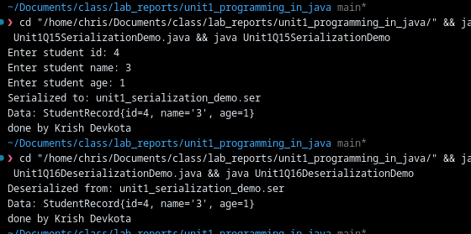
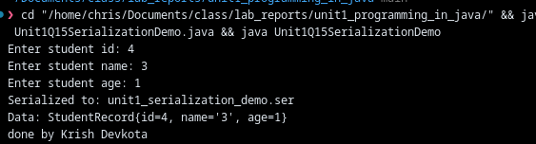

Conclusion:
In this lab, various Java programs were implemented to understand both basic and advanced programming concepts. The exercises started with simple tasks such as displaying messages and taking user input, which helped in learning the basic syntax and structure of Java. Further programs involving calculations like sum, average, finding the smallest number, and swapping values improved logical thinking and problem-solving skills. The lab also covered important Object-Oriented Programming concepts such as parameterized constructors, interfaces, and method overriding, which are essential for writing organized and reusable code. In addition, user-defined exceptions were used to understand error handling in Java. The use of ArrayList, Hashtable, and Comparator provided knowledge about managing and sorting data using Java’s collection framework. Advanced topics like synchronization helped in understanding multithreading and thread safety, while serialization and deserialization demonstrated how objects can be stored and retrieved from files. Overall, this lab provided a comprehensive understanding of Java programming and helped in building a strong foundation for developing real-world applications.

